**Grep commands:**

It is command used for searching plain-text data sets for patterns that match a regular expression.

Syntax:

grep pattern filename

We find a particular pattern in file mentioned.

grep -i pattern filename: to ignore case

grep -c pattern filename: to count reptation at start of sentence.

grep -c -i: to ignore case and count number of occurrences.

grep -l pattern filename1 filename2: with the file name where pattern is present.

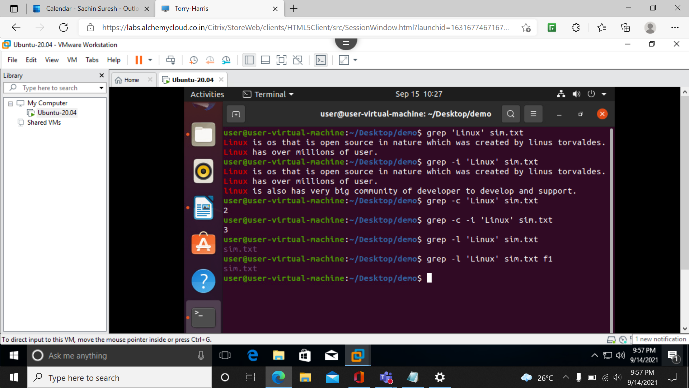

grep -w pattern filename: word highlighted in sentence

grep -o pattern filename: sub string

grep -ow pattern filename: only if full

grep -n pattern filename: with line number where present

grep -v pattern filename: all line except that where the pattern is present.

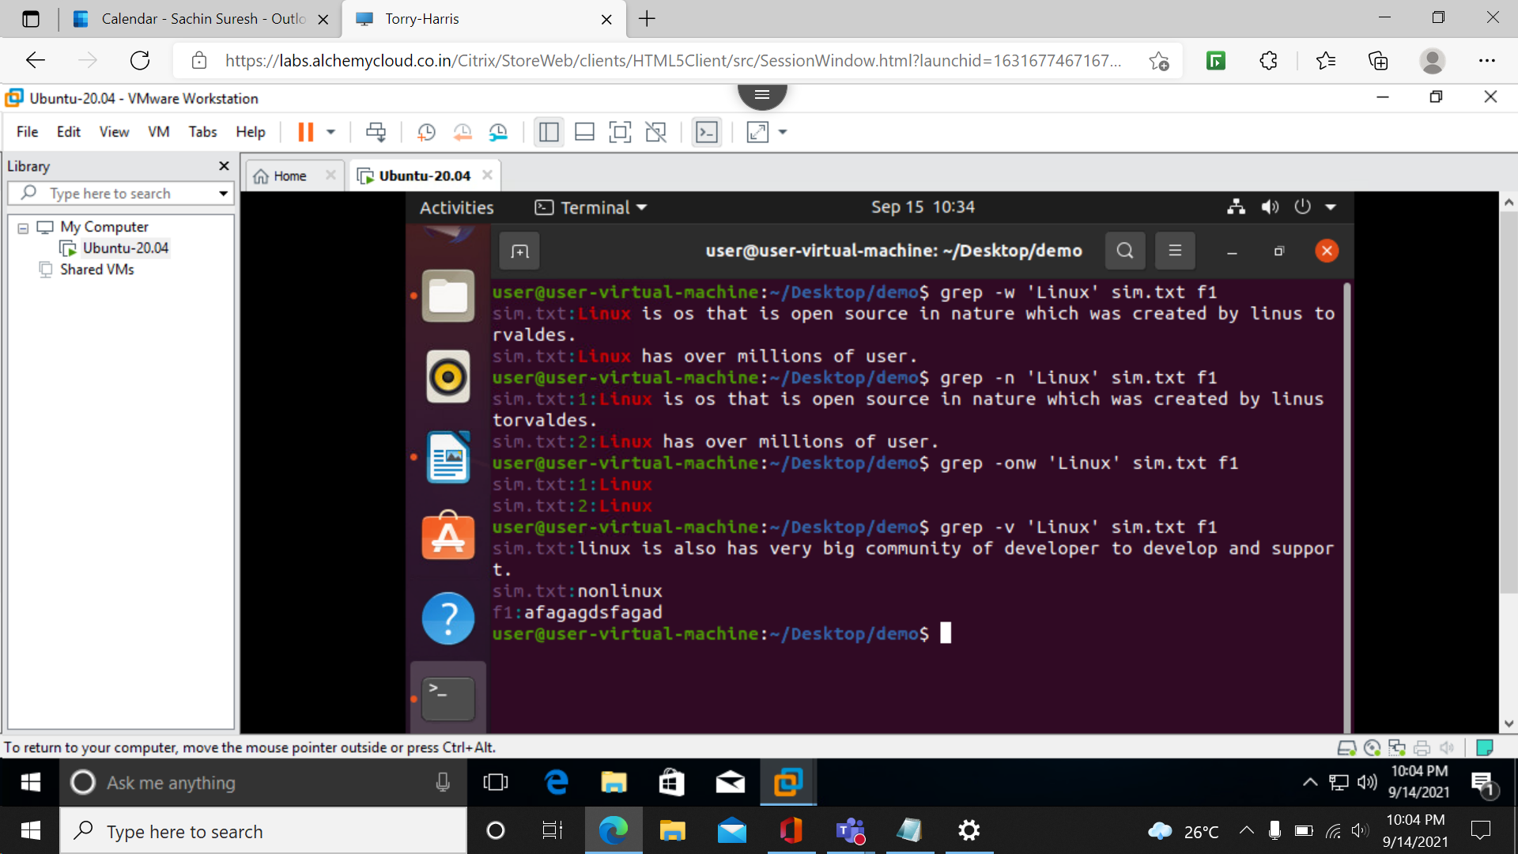

**Starts with and end with :**

grep ^pattern filename: if the line starts with the pattern

grep pattern$ filename: if line ends with the pattern.

starts with same and ends with the same.

grep ‘^pattern.*pattern$’ filename

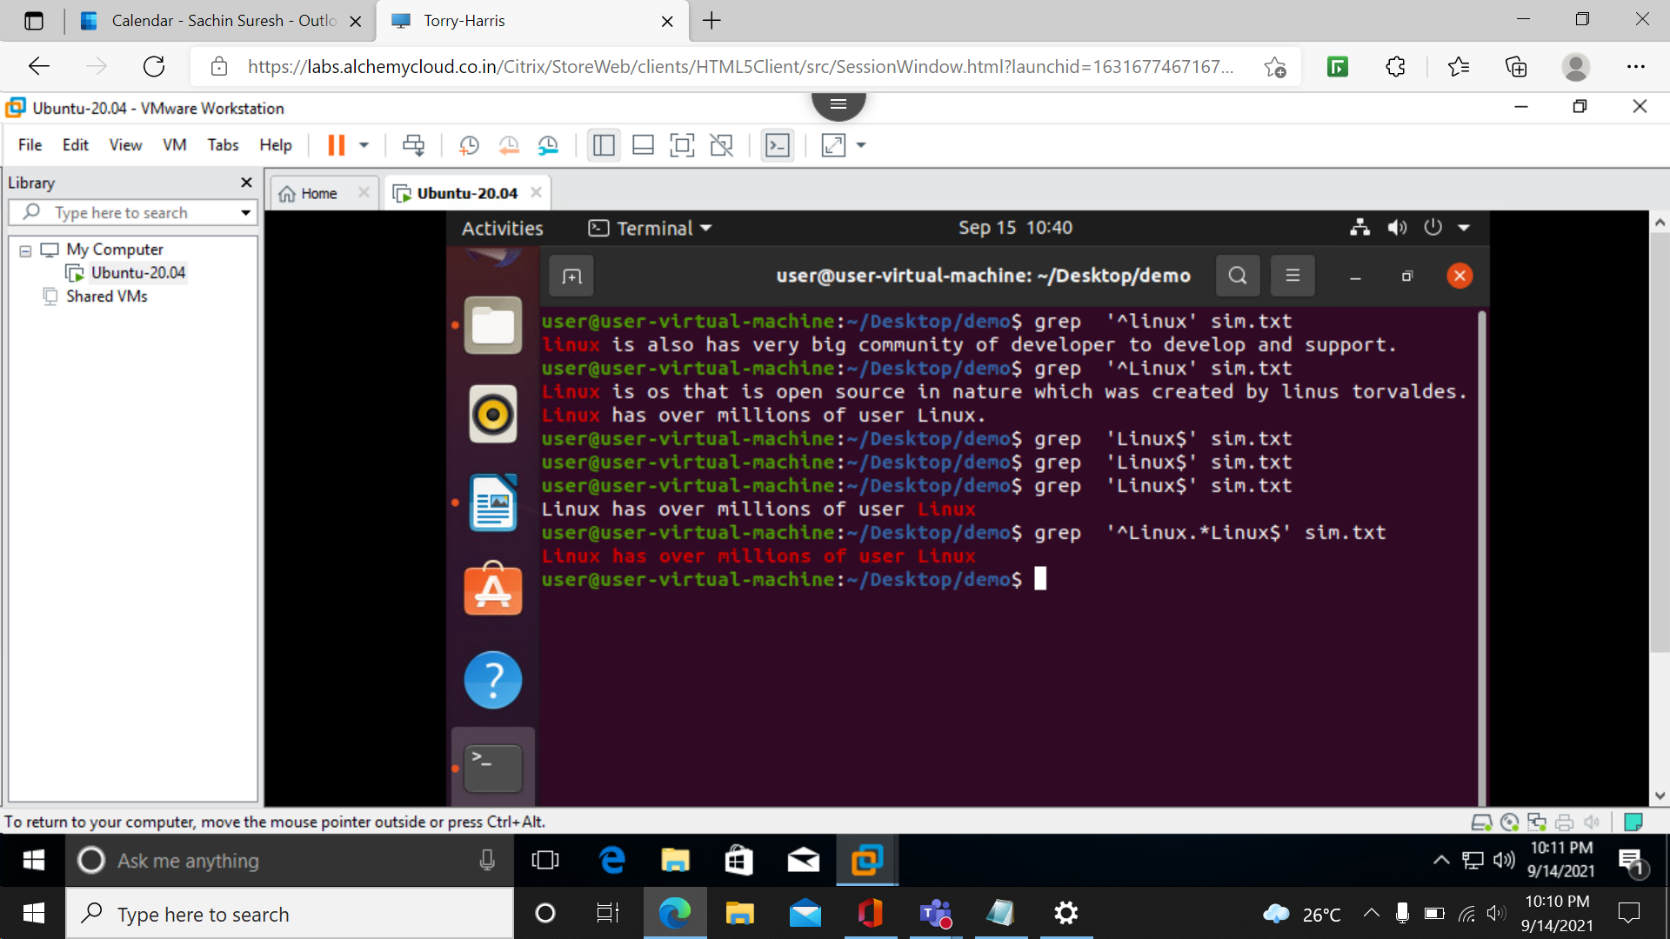

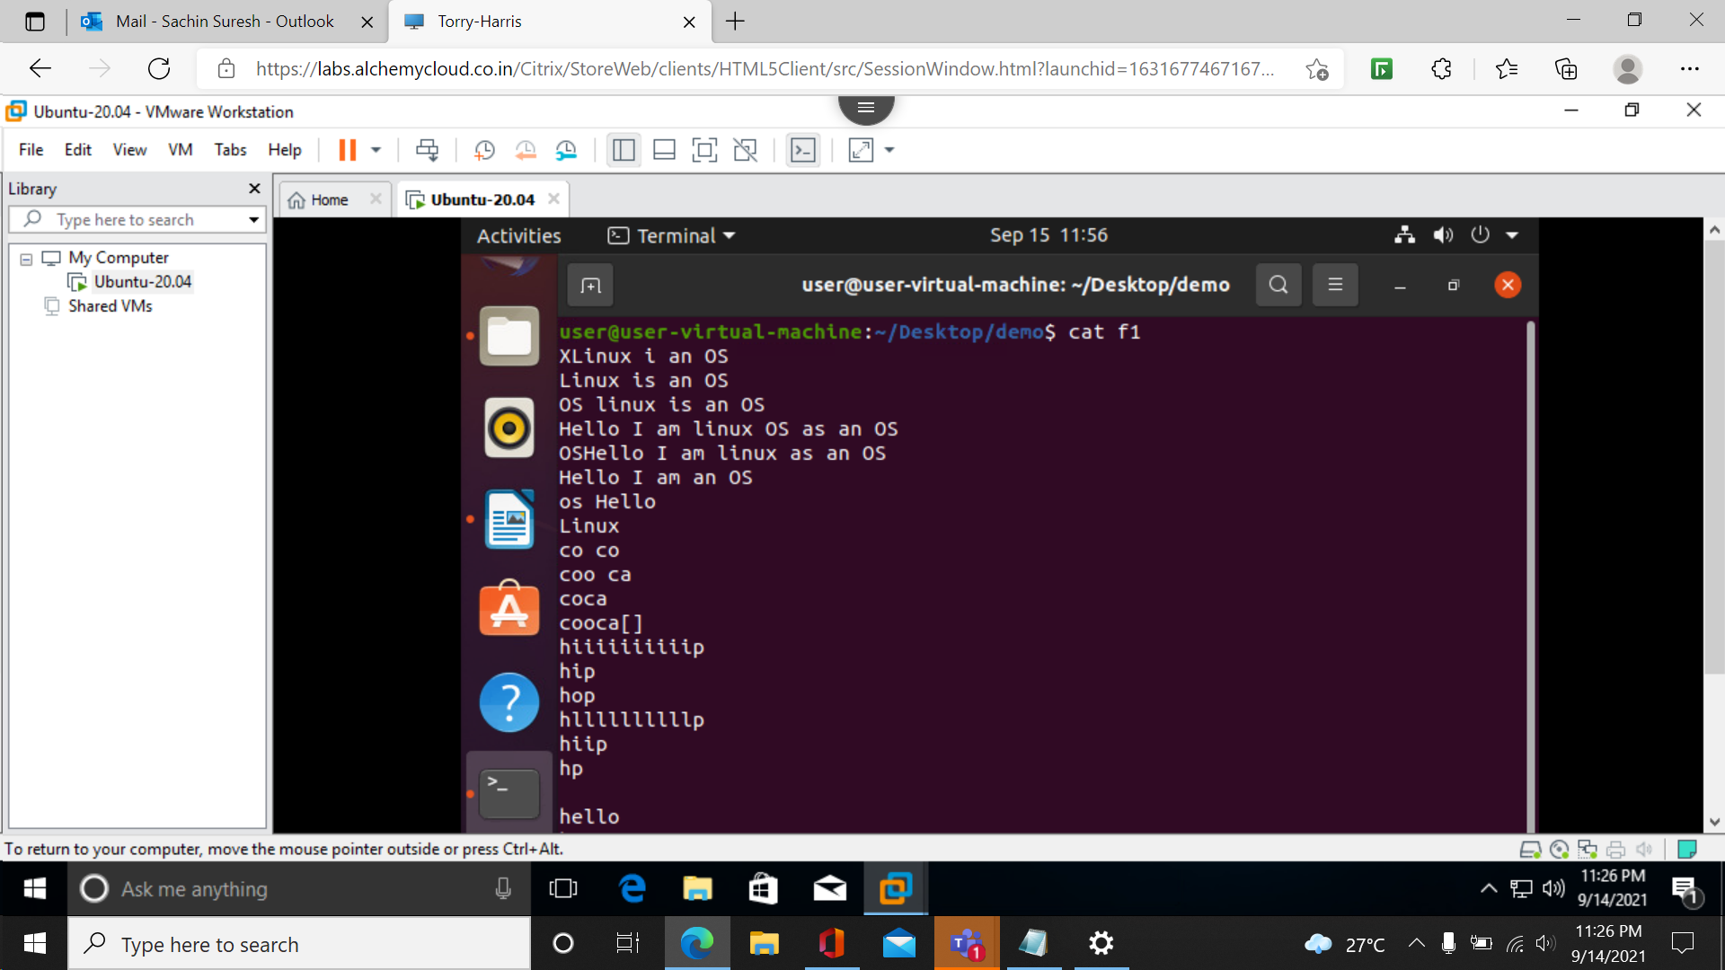

**[ ]: Matches any one of a set characters:**

[ ] with hyphen: Matches any one of a range characters

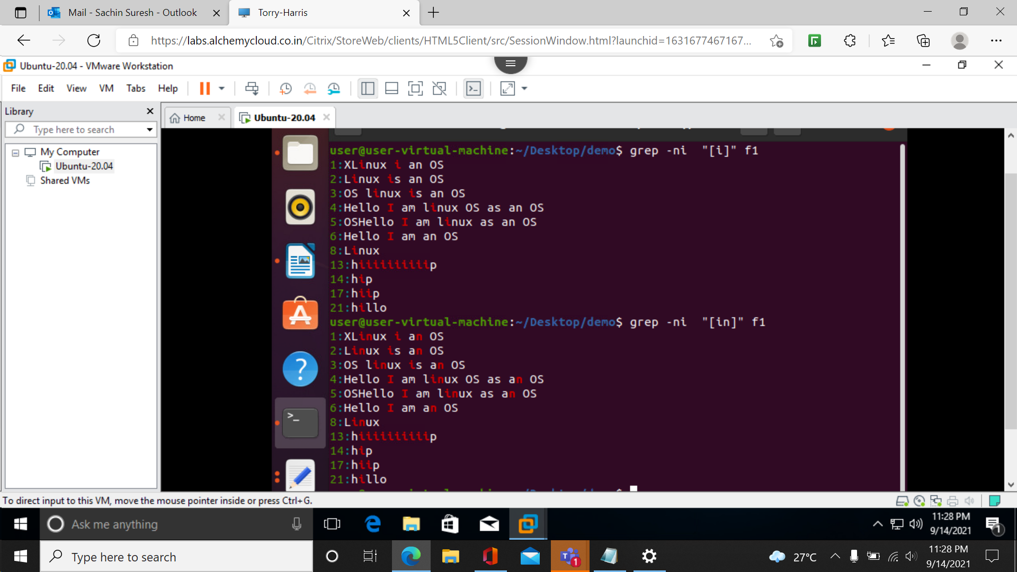

^: The pattern following it must occur at the beginning of each line

^ with [ ] : The pattern must not contain any character in the set specified

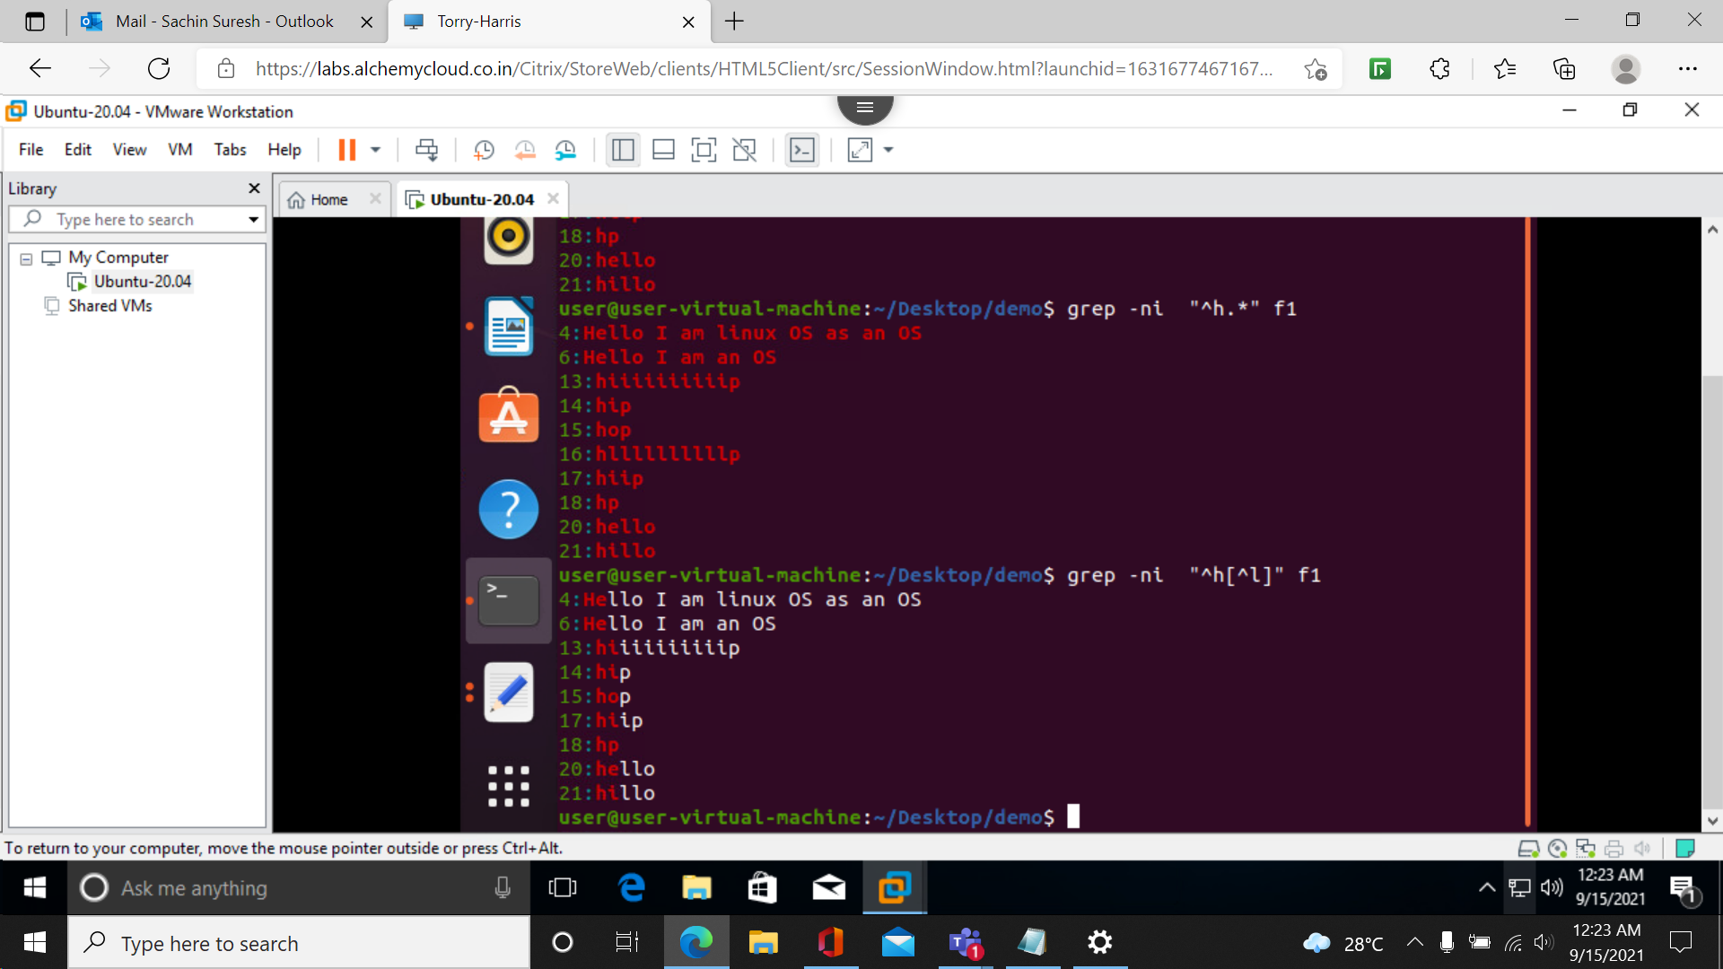

**. (dot): Matches any one character**

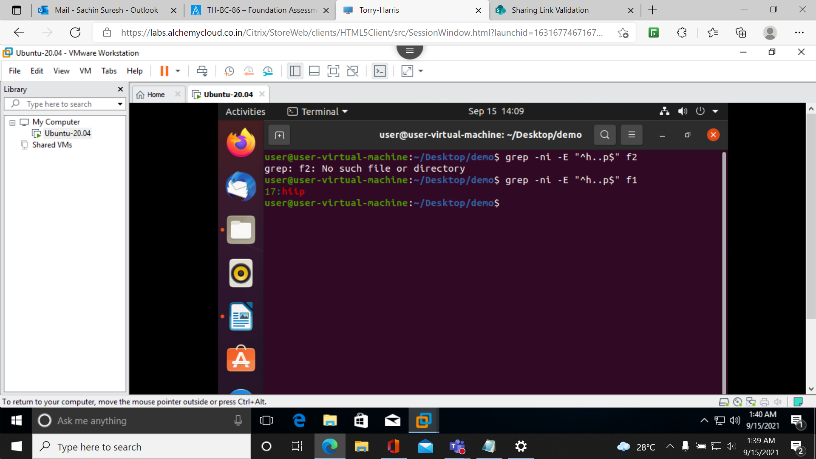

**CUT COMMAND:**

**Used to cutting out a section from each line of file and writing the result as standard output.**

**Cut –c position filename**

**Cut –c position-position filename**

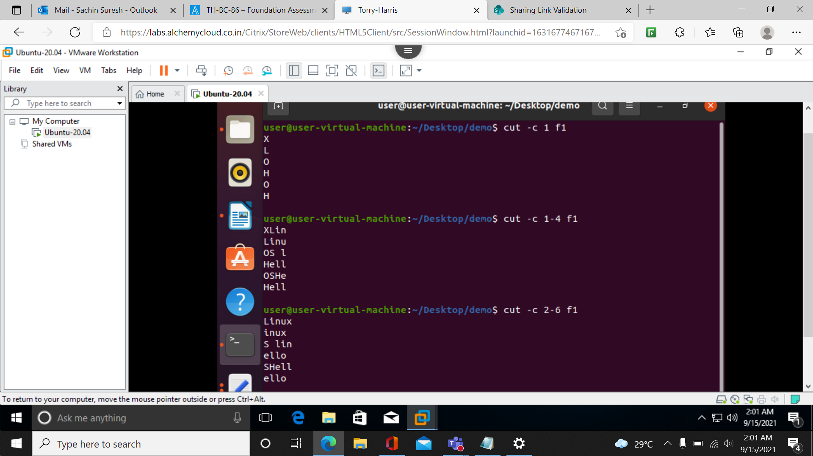

**Cut –c position, position file name**

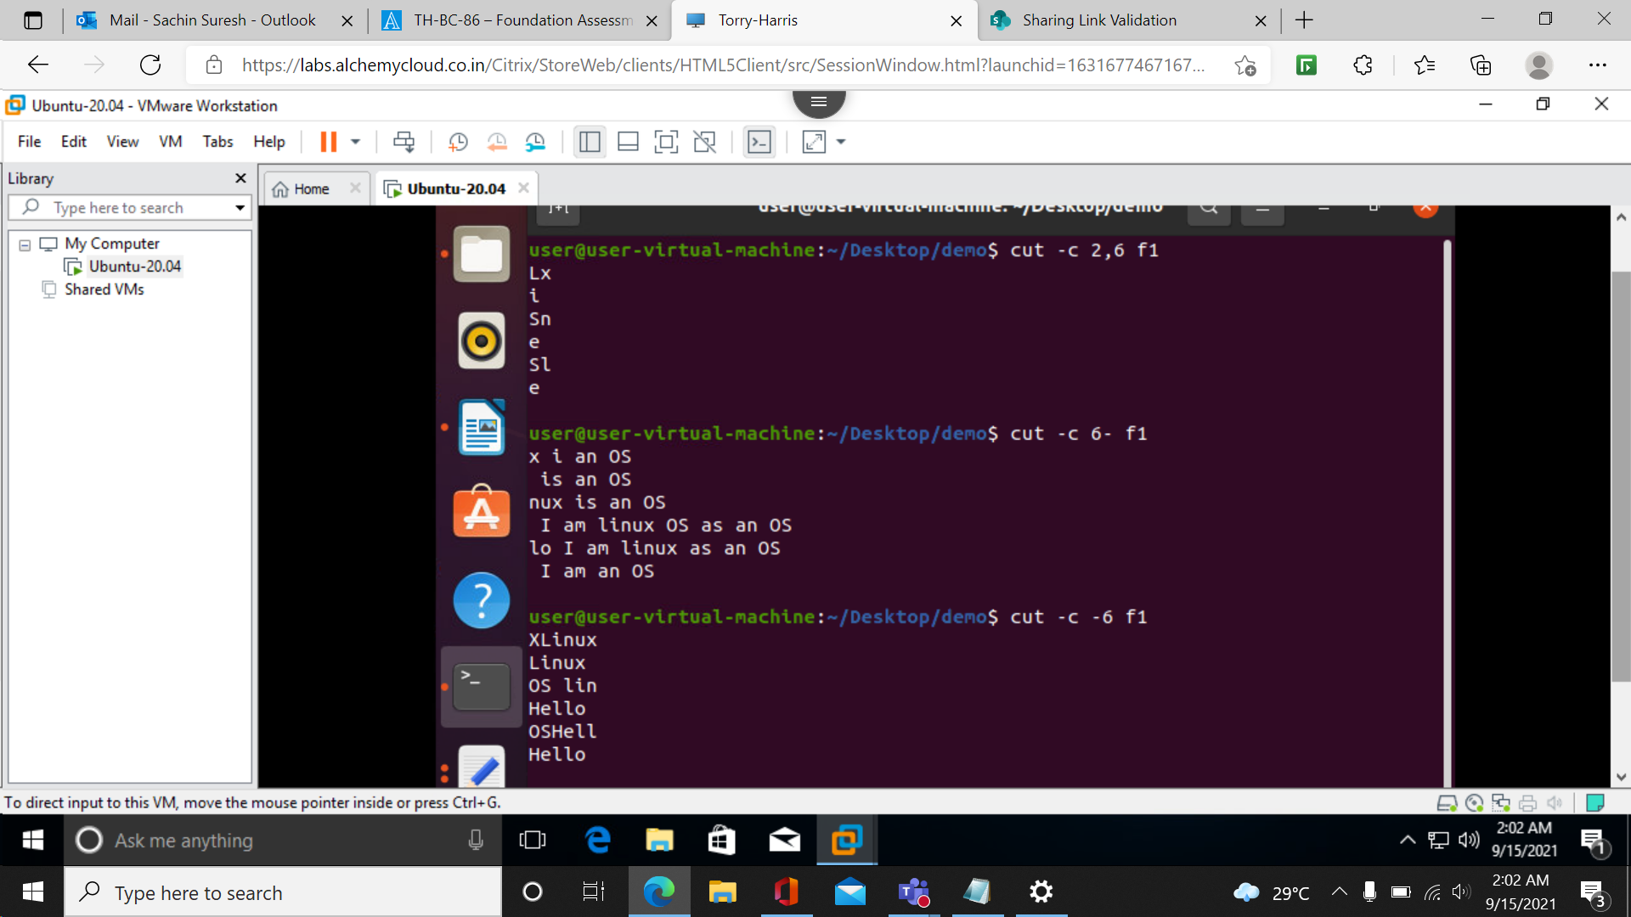

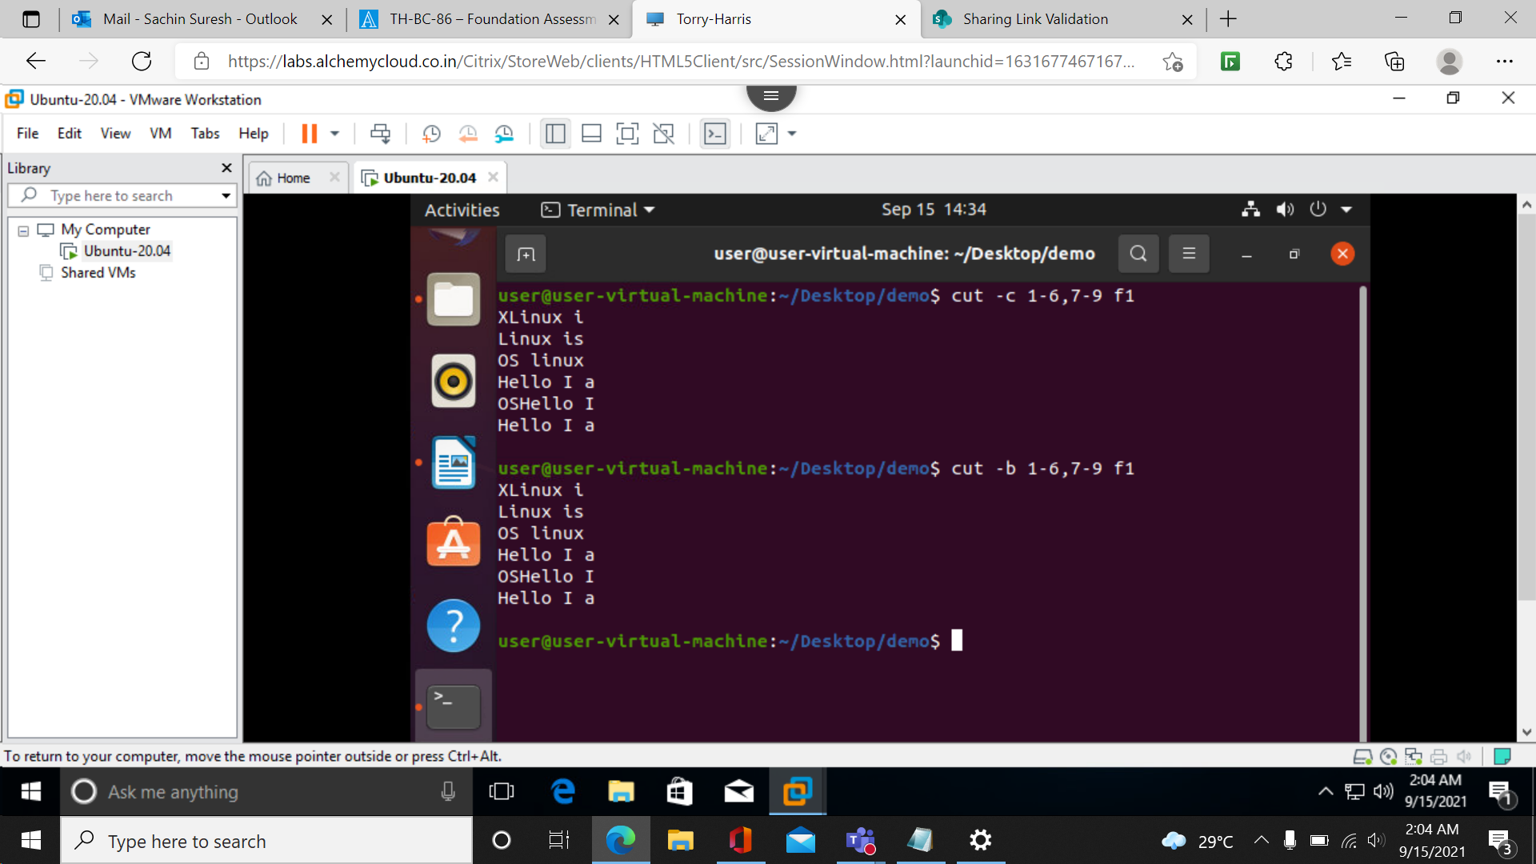

**-d(delimiter)**

**Till we encounter the character specifies for specified time things are printed.**

**Cut –d ‘character’ -f which occurrences file name**

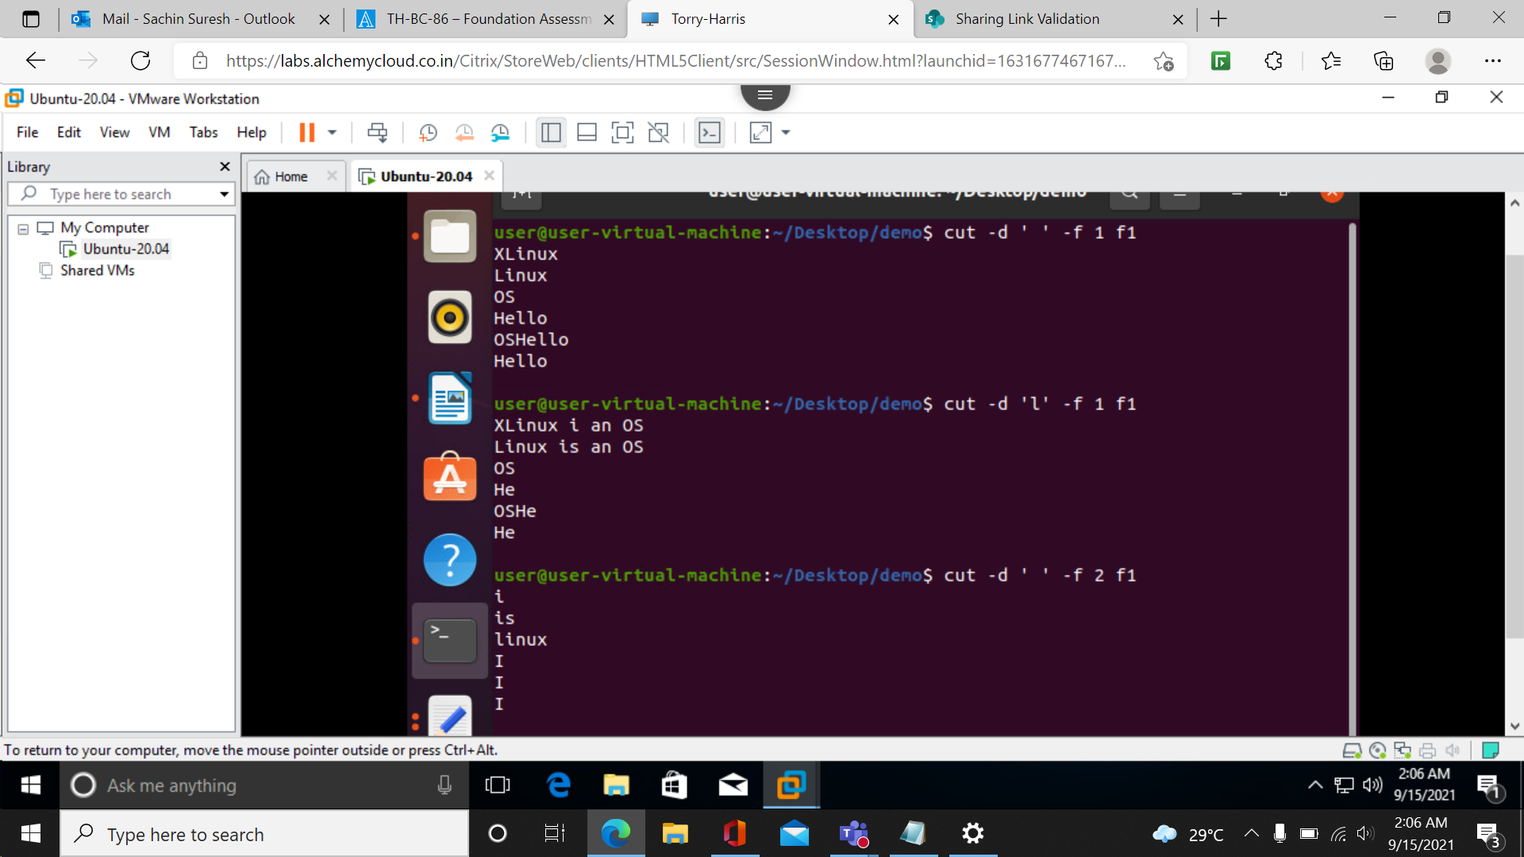

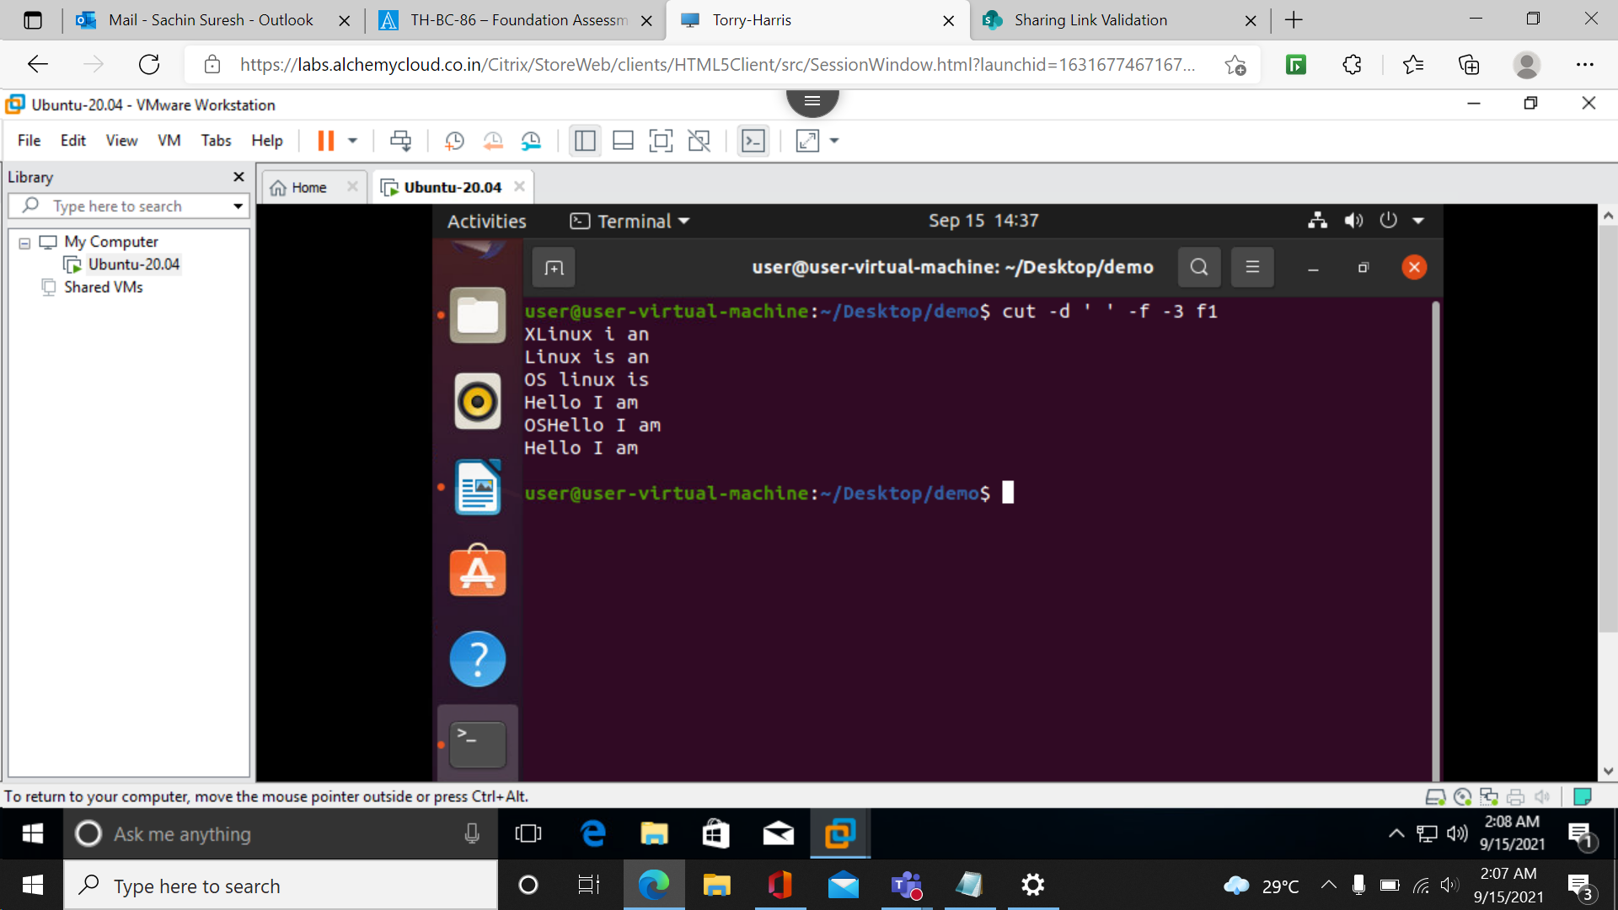

Compliment

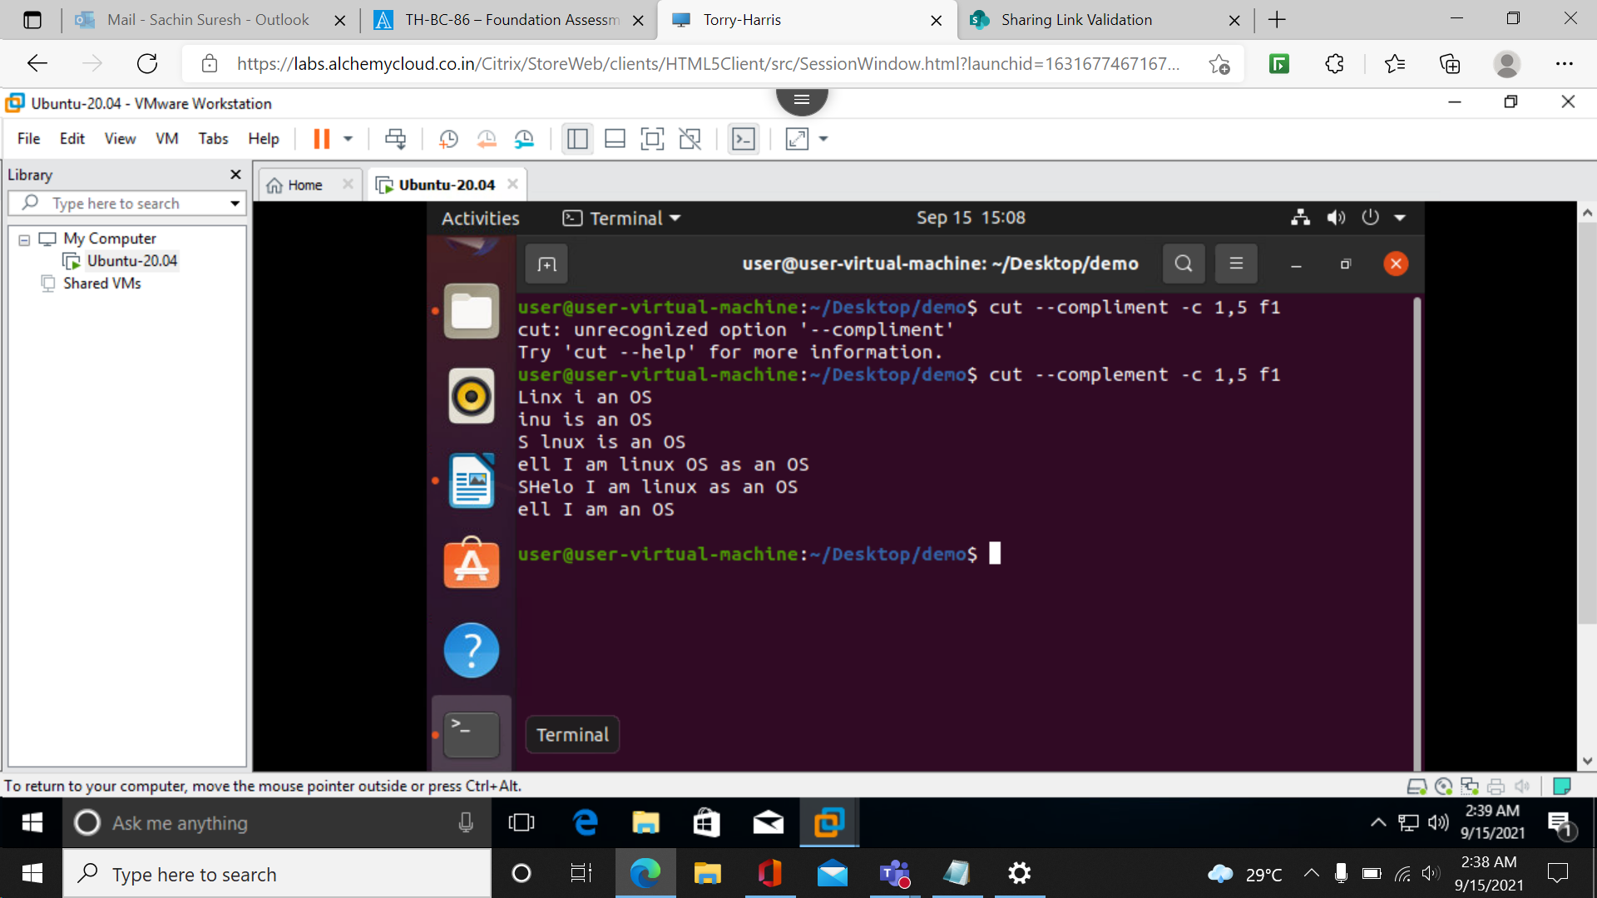

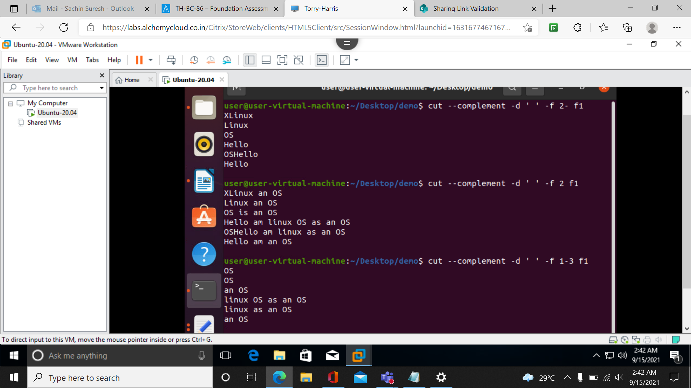

**To use more then 1 command at once:**

**We can use pipeline (|)**

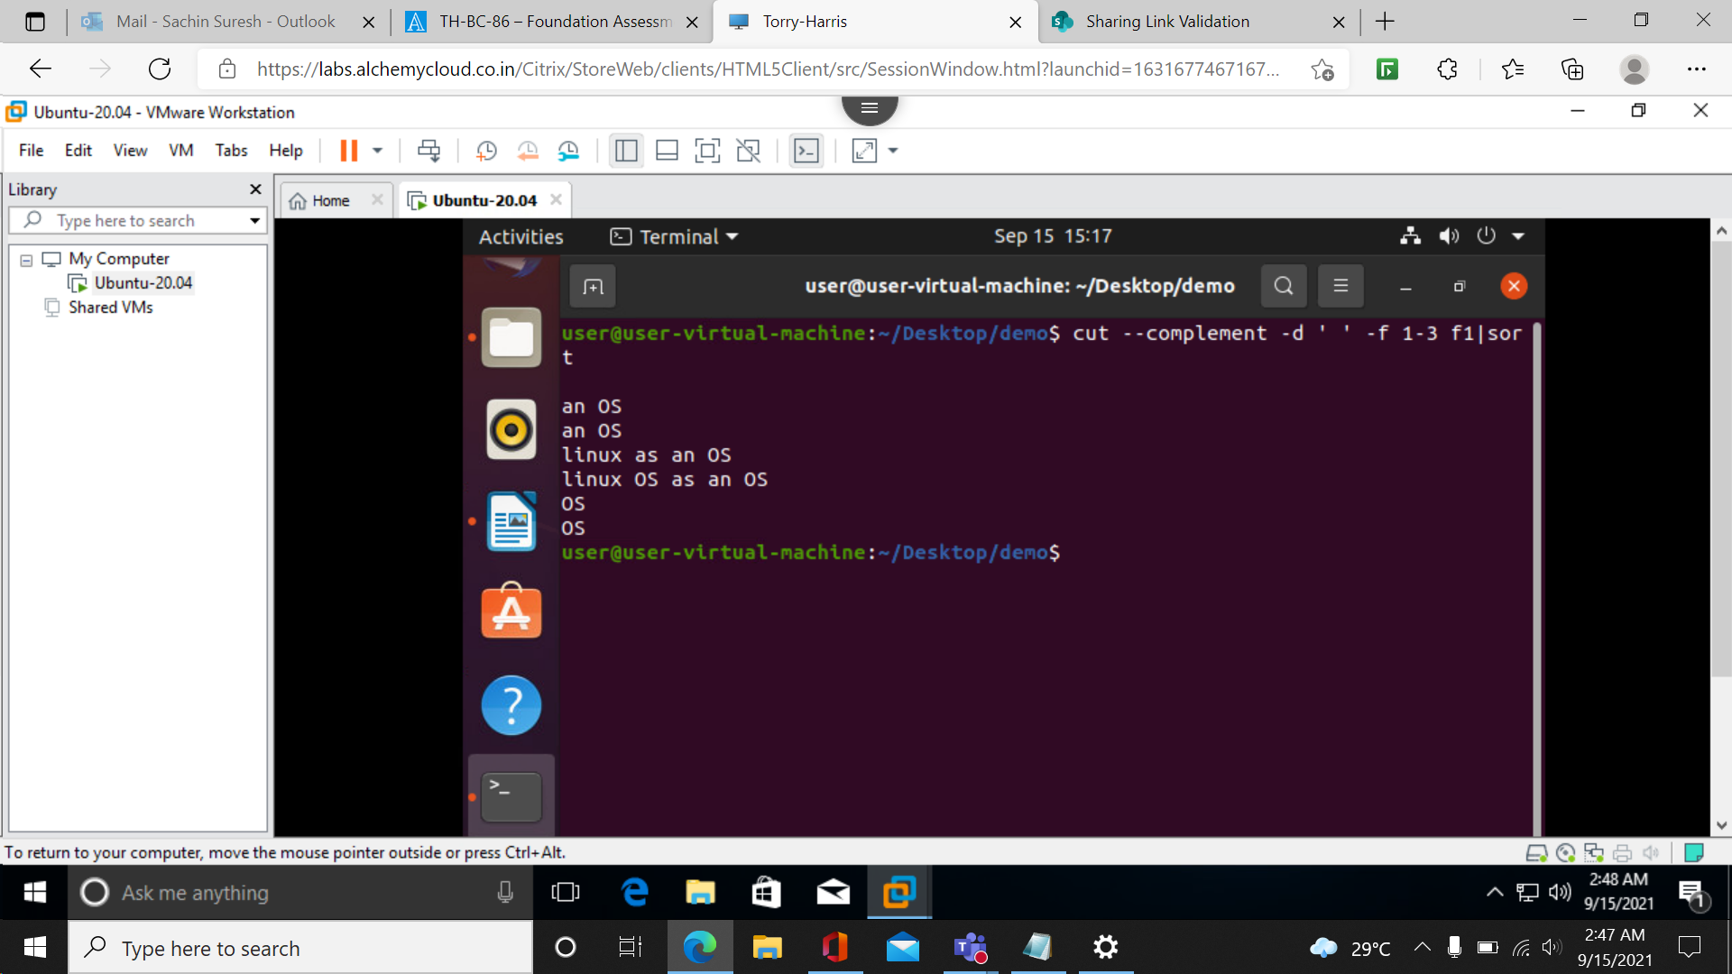

**To store output into a file**

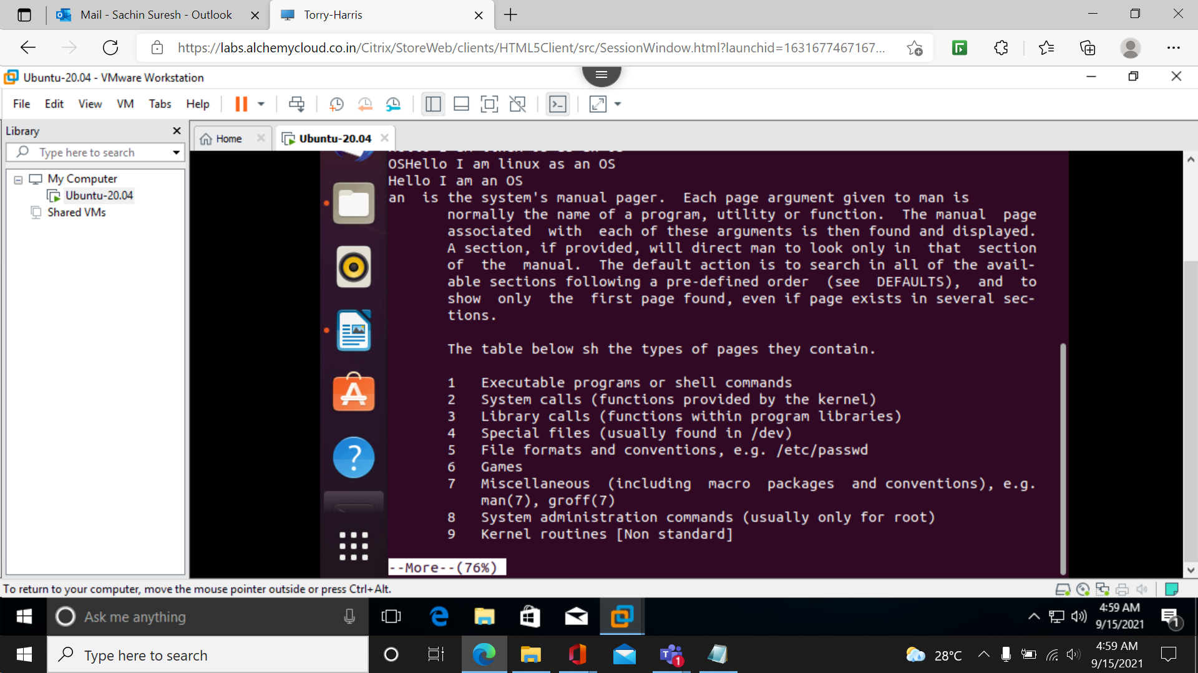

**Tr command** :used to transform

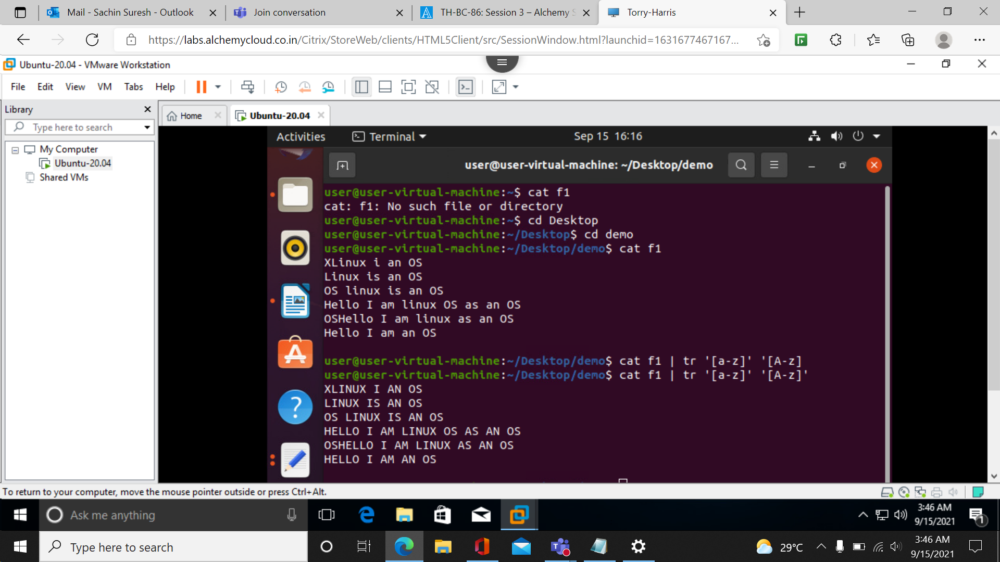

To convert to from lower to upper:

Two ways

Cat filename | tr ‘[a-z]’ ‘[A-Z]’

Cat filename | tr ‘[:lower:]’ ’[:upper:]’

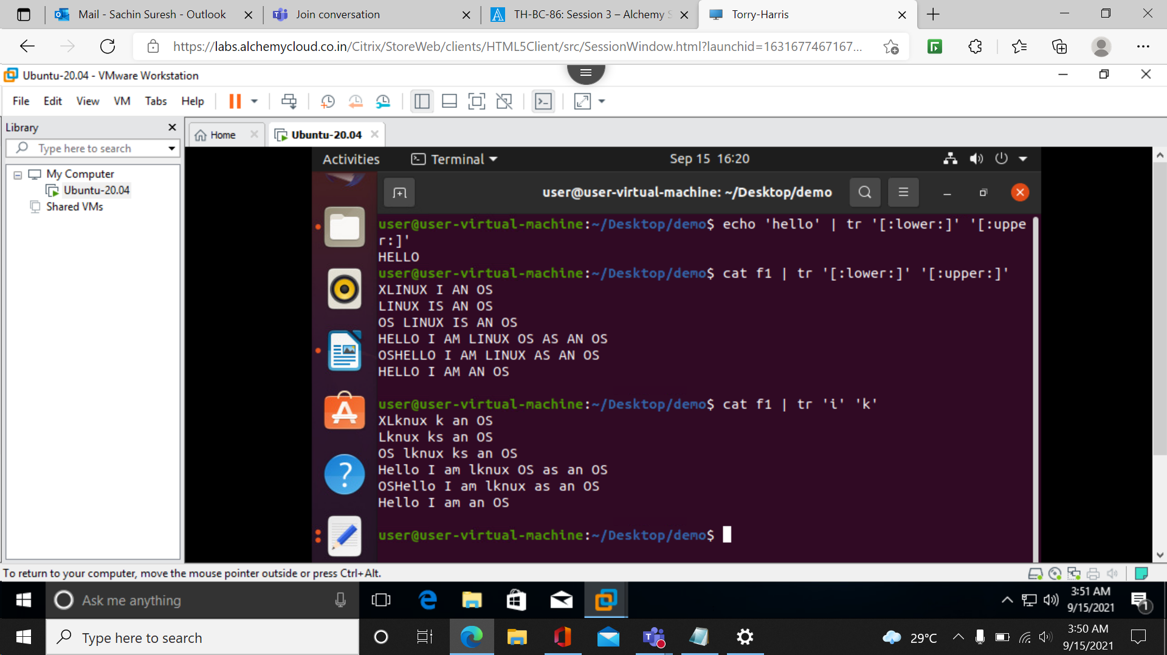

Can also used to replace one character to another charecter

Cat filename | tr ‘charecter1’ charecter2’

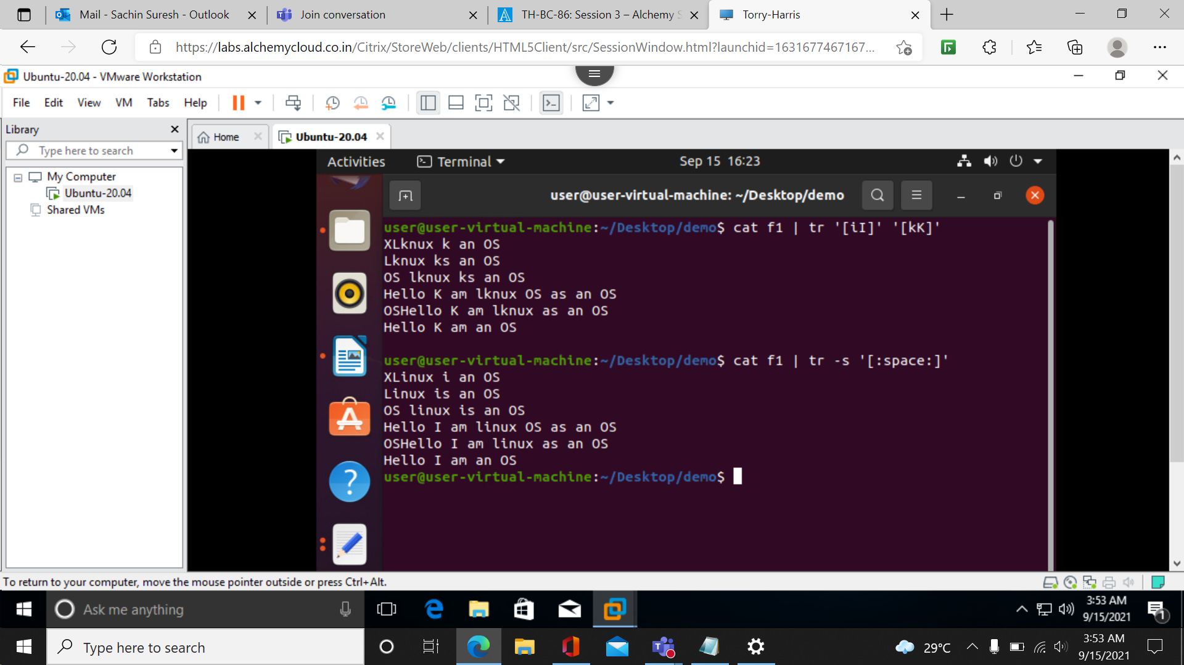

Can delete characters

Individual and also group of characters can be given at a time.

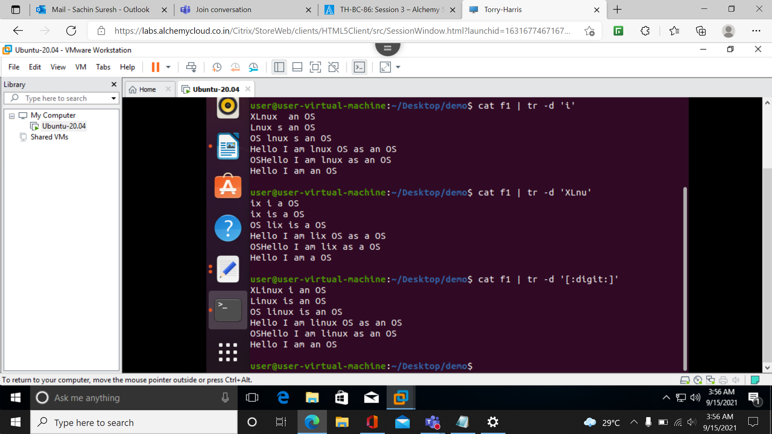

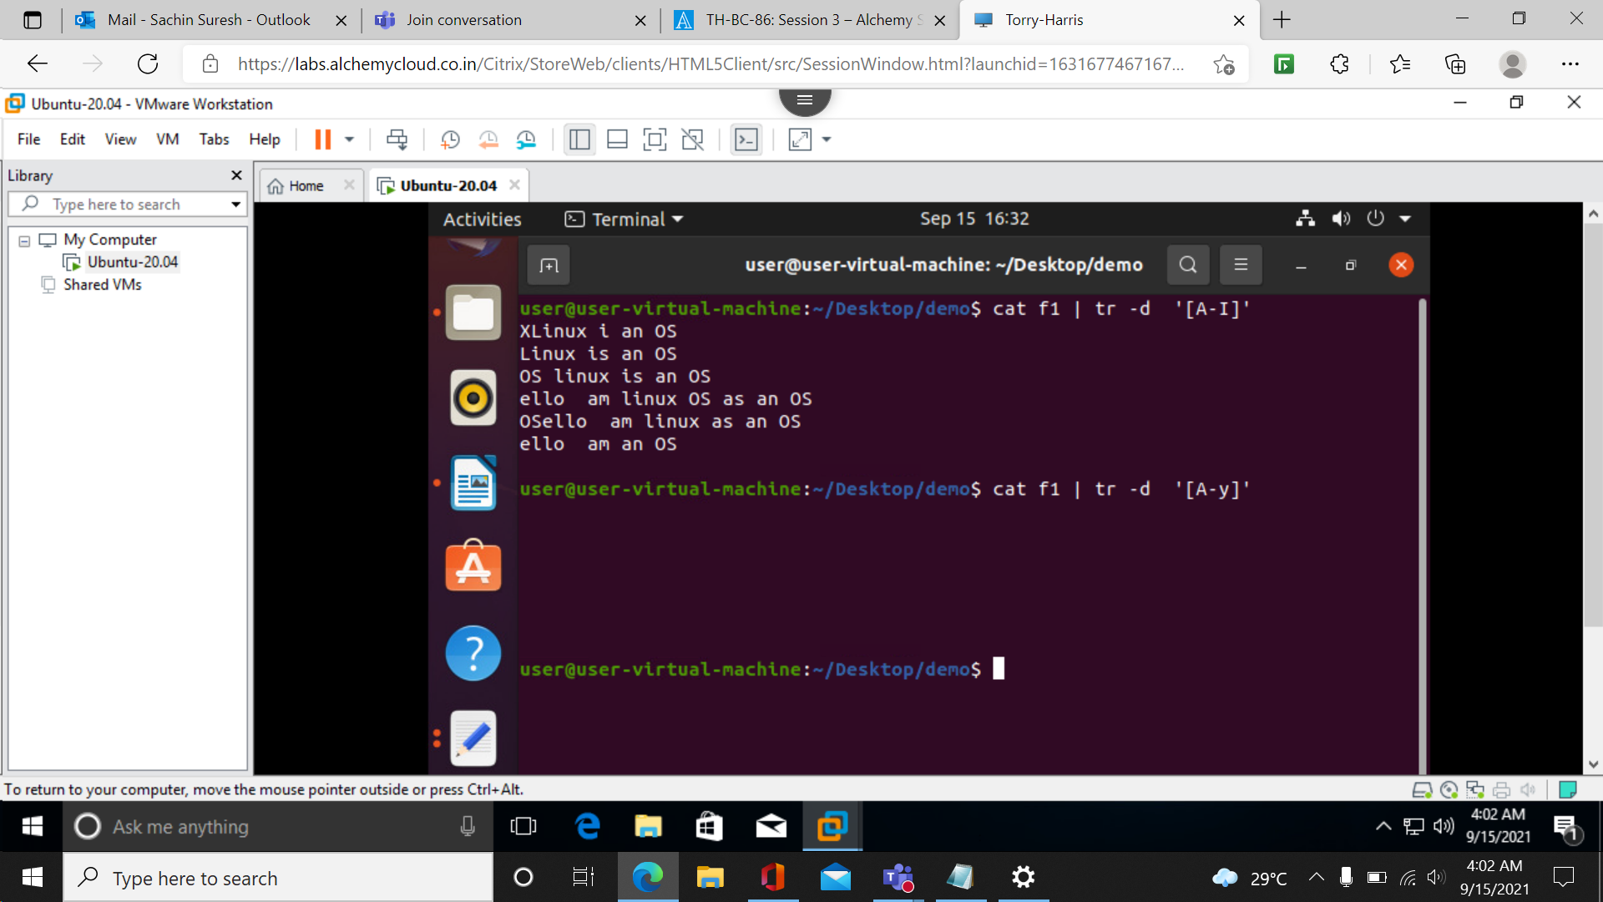

**More : to view very big text commands**

**More filename**

Enter key is used to navigate to next line

Space key is used to navigate to next page

B key is used to go back to previous line

Q key is to go back to terminal.

More –s filename squeeze the extra spaces.

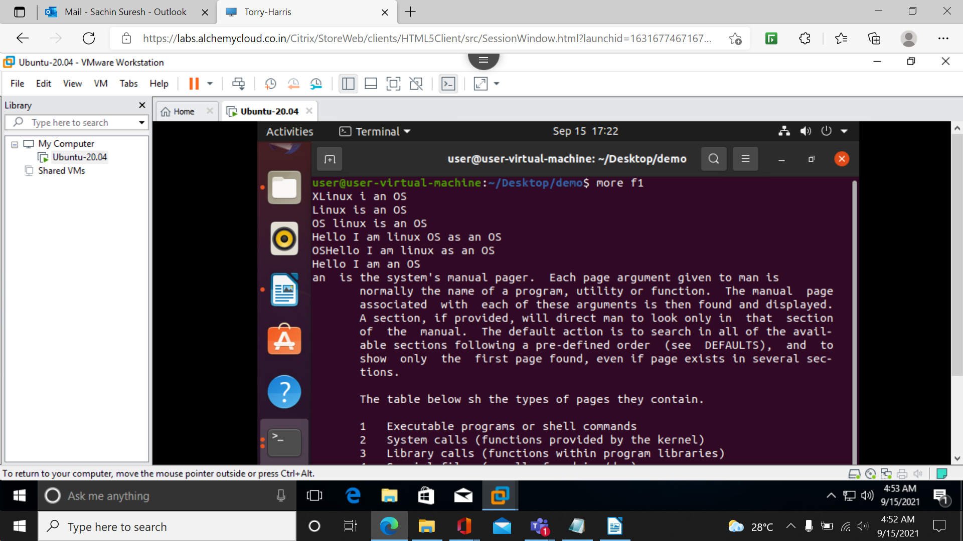

More –p filename

